

Department of Electronics and Communication Engineering

**Vasavi College of Engineering (Autonomous)**

ACCREDITED BY NAAC WITH ‘A++’ GRADE

IBRAHIMBAGH, HYDERABAD-500031

**CERTIFICATE**

This is to certify that the Mini project titled “Grain Moisture Meter” submitted by:

Arun Karnati 1602-21-735-072

Shiva kalyan Gupta 1602-21-735-115

Yashash Anirudh 1602-21-735-130

Tejasri 1602-20-735-113

Students of Electronics and Communication Engineering Department, Vasavi College of Engineering in partial fulfilment of the requirement of the award of the Degree of Bachelor of Engineering in Electronics and Communication Engineering is a record of the bonafide work carried out by them during the academic year 2023-2024.

V.Krishna Mohan

Assistant professor HOD - ECE

E.C.E Department

**INDEX**

|  |  |  |
| --- | --- | --- |
| **S NO** | **CONTENT** | **PG NO** |
| 1 | Abstract | 3 |
| 2 | Problem acknowledgement | 4 |
| 3 | Problem statement | 4 |
| 4 | Literature review | 5 |
| 5 | Components Involved | 6 |
| 6 | Flow of solution | 9 |
| 7 | Solution Presented | 11 |
| 8 | Results | 12 |
| 9 | Observation | 15 |
| 10 | Applications | 18 |
| 11 | Commercial Scope | 18 |
| 12 | Future Scope | 19 |
| 13 | Conclusion | 19 |
| 14 | References | 19 |

**1.ABSTRACT**

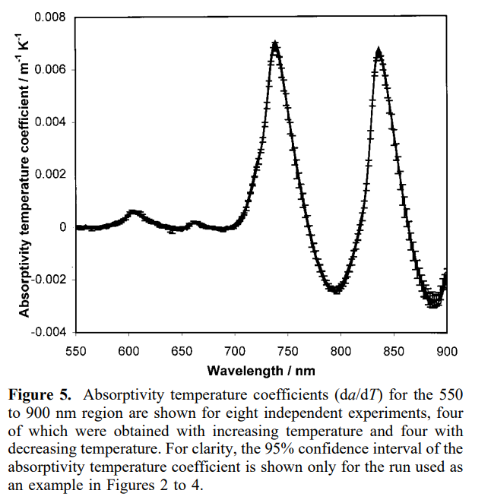Grain moisture meter is used to measure the moisture content of the grains. The principle being employed in this project is the behaviour of water molecule to different wavelengths of IR rays (IR spectroscopy of water). Water molecules absorb maximum IR radiation when the wavelength is of 850nm, if we can make use of this property of the water then we can show a

variation between the grains of different moisture levels by exploiting the absorptivity phenomenon of water, in order to achieve this first we prepare grain samples of different moisture levels, after this we measure the moisture content of the grain of a particular gradient using a standard method, and then we measure how much voltage is it absorbing when the sample is placed in between the 850 nm IR transmitter array and photodiodes. Based on the amount of water content in the grains the amount of radiation absorbed by the grain varies, The exact values of the moisture content v/s the voltage is noted. By using linear regression on the collected data set after cleaning the dataset set, we get an equation which is fed into a microcontroller with inbuilt ADC, now the microcontroller collects the analog value of the voltage and by using the regression curve it can give the estimate of the moisture content present in the given sample.

This microcontroller can be fed with the regression curves of different grains and we can use the same setup to measure the moisture contents of different samples without any additional enhancements.

Once the moisture content is obtained its displayed out using a 0.96’’ OLED screen, if we had regression curves of different grains then we can use a select button in order to select between different types of grains whose moisture content can be analysed by using our machine setup.

**2. PROBLEM ACKNOWLEDGEMENT**

One of the major problems that is commonly encountered during trading the paddy grains to brokers is the factor of moisture percentage in the grains, this is one of the key factors which decides the price of the paddy.

Due to the high price of the moisture measuring meters which range from around INR 5000 to INR 15,000 which is unaffordable by a small farmer, so our project aims to provide a simple and cost-effective method for measuring the moisture content of the grains.

**3.PROBLEM STATEMET**

Design a grain moisture meter employing a principle that takes care of the trade-off between accuracy and cost, making sure that the so designed method must be easy to use and cost effective.

**4.LITERATURE REVIEW**

**Introduction**:

Grain moisture content is a critical factor influencing the quality, storage, and market value of grains. Traditional moisture measurement methods often involve destructive or time-consuming processes, prompting the need for rapid, non-destructive techniques. This literature review aims to explore the advancements in grain moisture meters, specifically focusing on the utilization of Near-Infrared Spectroscopy (NIR) technology for efficient and non-invasive moisture content determination in grains.

**Overview of Grain Moisture Meters:**

Grain moisture meters are indispensable tools in agriculture for assessing moisture levels in various grains. Accurate moisture measurement is crucial to prevent spoilage, ensure proper storage conditions, and maintain grain quality. Conventional methods, such as oven drying or capacitance-based meters, have limitations in terms of speed and destructiveness. Modern grain moisture meters, particularly those incorporating NIR spectroscopy, have emerged as promising alternatives, offering non-invasive, rapid, and reliable measurements.

**Application of Near-Infrared Spectroscopy (NIR):**

NIR spectroscopy, as discussed in "Analysis of water in food by near-infrared spectroscopy," demonstrates its effectiveness in non-destructive water content analysis in food products. The penetration depth of NIR light into grains allows for the identification of molecular structures associated with moisture content. This property has paved the way for integrating NIR technology into grain moisture meters, enabling quick and accurate moisture determination without compromising grain integrity.

**Development of Rapid-Detection Sensor for Rice Grain Moisture:**

The paper "Rapid-Detection Sensor for Rice Grain Moisture Based on NIR Spectroscopy" introduces a specialized sensor utilizing NIR spectroscopy for swift and precise moisture detection in rice grains. This innovation showcases the practical application of NIR technology in specialized grain moisture meters. By harnessing the unique properties of NIR light, this sensor facilitates rapid and non-destructive analysis, specifically catering to the needs of the agricultural industry.

**Advantages and Challenges:**

The integration of NIR spectroscopy in grain moisture meters offers several advantages, including speed, non-destructiveness, and accuracy. However, challenges related to calibration, sample variability, and sensor design persist, influencing the overall reliability and usability of these meters. Addressing these challenges is crucial for ensuring consistent and accurate moisture measurements across different grain types and conditions.

**Conclusion:**

The literature reviewed underscores the significant role of NIR spectroscopy in advancing grain moisture meter technology. Its application has revolutionized moisture analysis in grains, offering rapid, non-destructive, and reliable measurements. Despite the challenges, the continuous refinement and integration of NIR technology in grain moisture meters hold immense promise for enhancing agricultural practices, ensuring grain quality, and optimizing storage conditions.

**5.COMPONENTS INVOLVED**

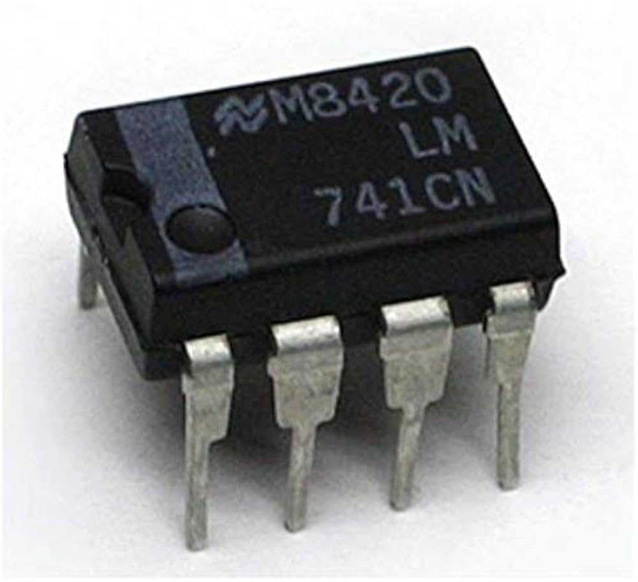 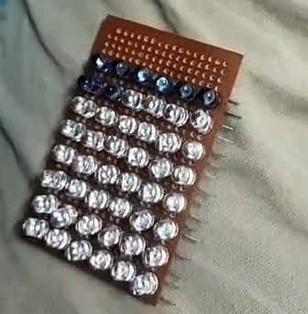

FIG: IC 741(OPAMP) FIG: IR transmitter array

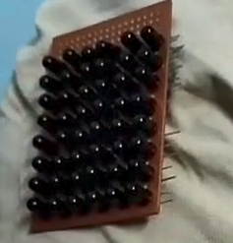 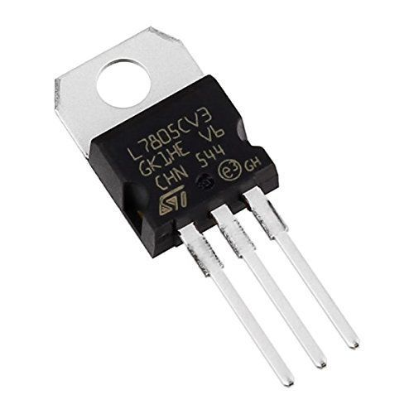

FIG: Photo diode array FIG: LM7805(Voltage regulator)

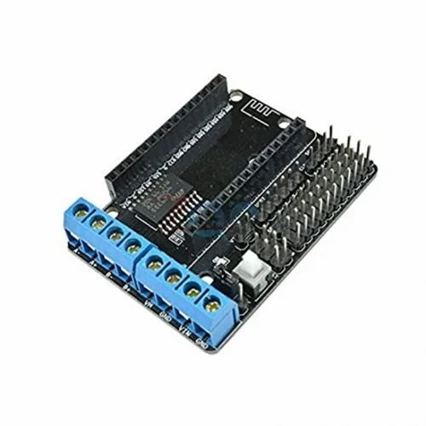 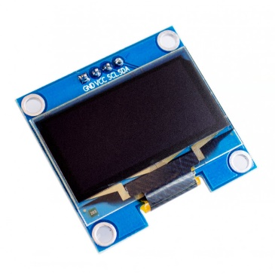

FIG: ESP 12E SHIELD FIG: OLED SCREEN

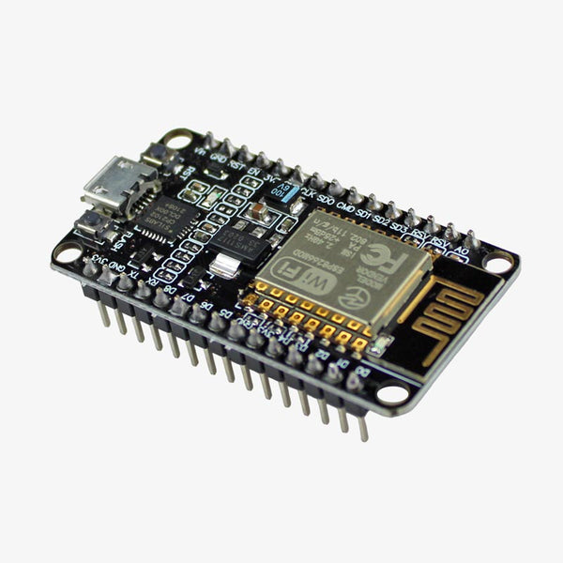 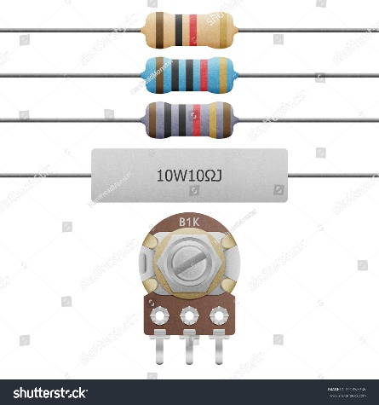

FIG: NODE MCU FIG: Various resistors

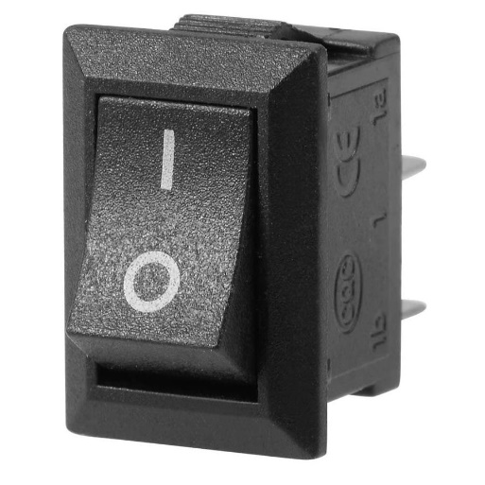 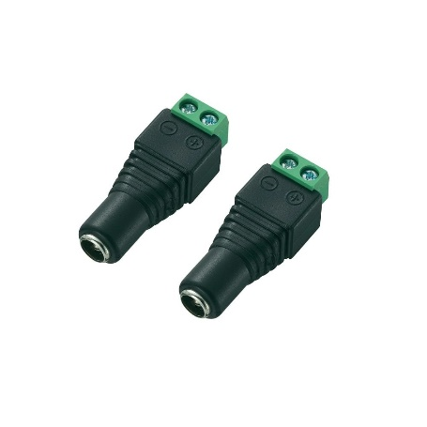

FIG: 250V 3A DC SWITCH FIG: JACK CONNECTOR

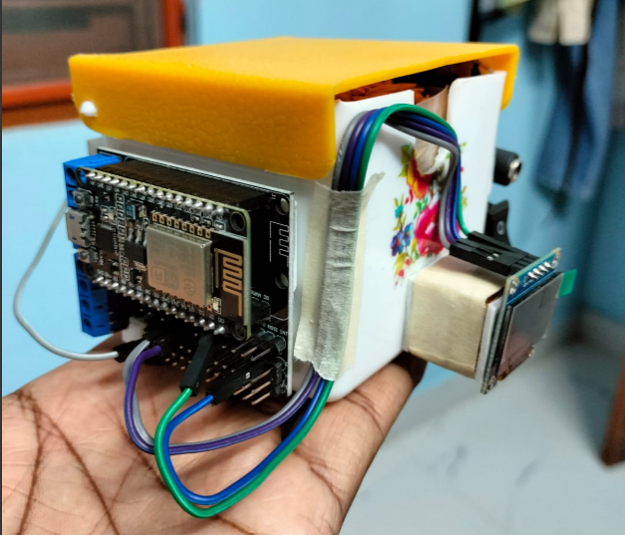 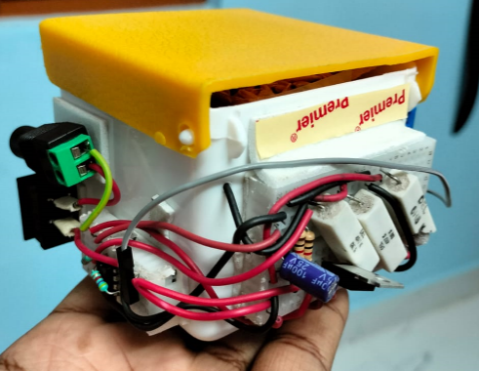

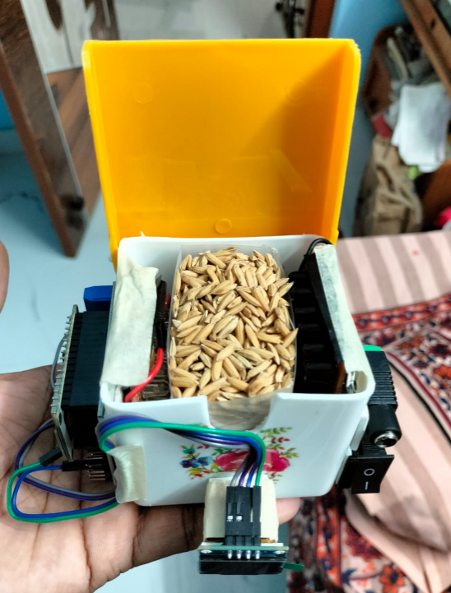

FIG: COMPLETE ASSEMBLED SMODEL VIEWS

**6. FLOW OF SOLUTION**

The solution proposed for this problem is divided into few steps and the steps are explained below:

**Sample preperation**

This step involves preperation of paddy grains with different moisture gradients, for this 5kg of completely sundried paddy grains are selected and soaked in warm water for 48 hours.

Once the grains absorb maximum amount of moisture content from the water, grains are placed in a hot air oven at 45-500C, 500g of sample is taken out of the oven at different time intervels 0min,5min,15min,30min,50min,75min 105min,145min and 195min now for each drying time 5samples are made each of 100g so we get 45 samples each of 100g weight.

The true rice grain moisture is determined by the 1050C constant weight method from the national standard GB5497-1985 (Determination of moisture content of grain and oil). Rice grain moisture is expressed as % of dry weight, out of 100g of sample of each gradient 50g of the sample’s moisture content is determined by the constant weight method and noted in a spreadsheet, by this we get the moisture content of 45samples.

**IR analysis of sample**

In this step the remaining 50g of the sample is placed in between the IR transmitter array and the photodiode array, based on the amount of moisture present in the grains the voltage drop across the resistor at the photodiode varies, this voltage drop is further amplified by an op-amp with AV = 5.

Using a voltmeter this voltage is noted down across the sample of particular time frame.

**Fitting a regression curve**

Once we get the voltage drop values for different gradients of paddy, using a polyplot( ) function in MATLAB we performed first order regression on the data set to get the curve fitting our data set.

Regression was performed multiple times by cleaning the data set, by cleaning we mean removing the values that are inaccurate and misleading the curve.

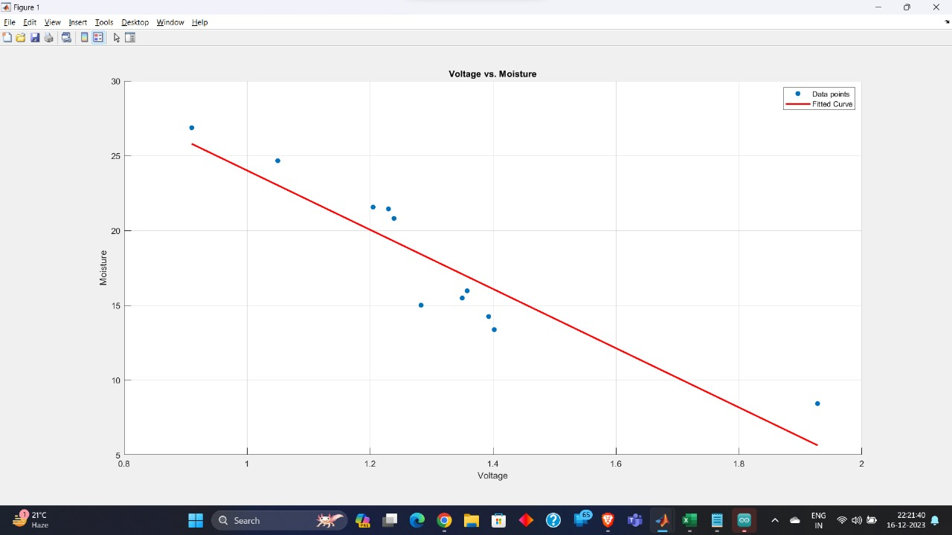

This is the regression curve obtained with the dependent variable being Moisture content and the independent variable being Voltage.

**Programming the microcontroller**

Once after the regression curve is obtained, this equation is fed into a microcontroller, in this case we are using NODEMCU which has an inbuilt 10bit ADC, the photodiodes are reverse biased and the +ve terminal of the photodiode is connected to a 500ohm resistor, the voltage drop across the 500ohm resistor is given as an input to an op-amp non inverting amplifier with the voltage gain being 5.

The output of this non inverting amplifier is given to microcontroller which converts the analog voltage to digital format, we program the microcontroller to convert back this digital value into analog voltage using the formula:

V= (3.3*Dv)/1024

Once after this digital voltage is converted back to the analog voltage, the moisture percentage is calculated using the obtained regression curve, the so obtained moisture value is displayed on the 128*32 OLED screen using I2C protocol.

**7. SOLUTION PRESENTED**

The presented solution meets our project objectives and mainly the employed method is cost efficient as well.

**Component selection**

We used IR transmitters which transmit IR rays of 850nm in order to reduce the model cost and also at the same time get a good accuracy, because the absorption pattern of water molecules get a peak at 850nm as well as at 3200nm.

**Assembling of components**

After the formulation of regression curve, microcontroller is programmed in the desired way and all the components are assembles together along with the grain compartment.

**Procedure**

Once the model is ready, we have to fill the grain compartment with paddy and turn on the system, after the completion of startup routine the system displays the moisture content of the grains in the grain chamber of the designed model.

**Testing**

After the development of the model we have to test the model for its accuracy, for that from the available 45 samples of each gradient (50g is available) we have to measure the moisture content of this 50g of grains using our model and record the value against the sample number, after this we have to use constant weight method in order to find the exact moisture content of the grains.

Once the true moisture content of the grains is determined and we also have the moisture content values given by the designed model, we can use Sum of squares and root mean square error method and these values determine the accuracy of the designed model.

Apart from this we can also perform corelation between the obtained values and the actual values which determines how accurate is our model predicting the moisture content of the grain sample in the grain compartment.

But, due to time constraint we were unable to provide the accuracy report of the model we have designed, we aim to provide the accuracy certificate of our model as soon as possible.

**8.RESULTS**

We have collected the moisture content of the paddy grains and here we present the moisture content readings of the paddy grains

|  |  |  |  |  |
| --- | --- | --- | --- | --- |
| **SAMPLE NUMBER** | **W1(weight before heating)** | **W1 gross** | **W2(net weight after heating)** | **Moisture** |
| UNUSED SAMPLE | 69.3773 | 20.3835 | 67.66 | 8.424951554 |
| 37 | 20.693 | 20.693 | 14.7941 | 28.50674141 |
| 38 | 10.336 | 10.336 | 8.3378 | 19.33243034 |
| 39 | 20.5093 | 20.5093 | 15.1077 | 26.33732014 |
| 40 | 20.6474 | 20.6474 | 17.6571 | Not accurate |
| 41 | 20.25449 | 20.25449 | 15.0787 | 25.55379079 |
| **AVG** |  |  |  | **23.74118042** |
| **5 mins** |  |  |  |  |
| 45 | 20.5493 | 20.5493 | 17.1254 | 16.66188143 |
| 42 | 20.3118 | 20.3118 | 15.57 | 23.34505066 |
| 44 | 20.287 | 20.287 | 15.9129 | 21.56109824 |
| 46 | 20.0144 | 20.0144 | 15.9504 | 20.30538013 |
| 43 | 20.0585 | 20.0585 | 15.1119 | 24.66086696 |
| **AVG** |  |  |  | **21.30685548** |
| **15 mins** |  |  |  |  |
| 2 | 20.2902 | 20.2902 | 17.2553 | 14.95746715 |
| 4 | 20.4763 | 20.4763 | 16.2422 | 20.67805219 |
| 11 | 20.0657 | 20.0657 | 15.7642 | 21.43707919 |
| 10 | 20.0619 | 20.0619 | 16.714 | 16.6878511 |
| 9 | 20.209 | 20.209 | 17.1768 | 15.00420605 |
| **AVG** |  |  |  | **17.75293114** |
| **30 mins** |  |  |  |  |
| 15 | 20.078 | 20.078 | 16.5534 | 17.5545373 |
| 14 | 20.0599 | 20.0599 | 16.9542 | 15.48213102 |
| 16 | 20.078 | 20.078 | 16.425 | 18.19404323 |
| 26 | 20.2758 | 20.2758 | 16.6357 | 17.95292911 |
| 3 | 20.0165 | 20.0165 | Not accurate | ---------- |
| **AVG** |  |  |  | **17.29591017** |
|  |  |  |  |  |
| **SAMPLE NUMBER** | **W1(weight before heating)(net)** | **W1 gross** | **W2(net weight after heating)** | **Moisture** |
| **50 mins** |  |  |  |  |
| 23 | 20.048475 | 20.048475 | 16.5738 | 17.3313681 |
| 12 | 20.01 | 20.01 | 17.37 | 13.1934033 |
| 30 | 20.0262 | 20.0262 | 17.18 | 14.21238178 |
| 13 | 20.002 | 20.002 | 16.92 | 15.40845915 |
| 24 | 20.032 | 20.032 | 16.5766 | 17.24940096 |
| **AVG** |  |  |  | 15.47900266 |
| 75 mins |  |  |  |  |
| 21 | 20.0725 | 20.0725 | 14.8999 | 25.76958525 |
| 18 | 20.0861 | 20.0861 | 14.8522 | 26.05732322 |
| 20 | 20.0118 | 20.0118 | 15.0105 | 24.99175486 |
| 19 | 20.0956 | 20.0956 | 14.763 | 26.53615717 |
| 1 | 20.0209 | 20.0209 | 14.6413 | 26.86992093 |
| **AVG** |  |  |  | 26.04494829 |
| **105 min** |  |  |  |  |
| 25 | 20.0654 | 20.0654 | 16.155 | 19.48827335 |
| 27 | 20.0203 | 20.0203 | 14.9018 | 25.56654995 |
| 31 | 20.0379 | 20.0379 | 15.3614 | 23.33827397 |
| 17 | 20.0065 | 20.0065 | 15.065 | 24.69947267 |
| 8 | 20.0397 | 20.0397 | 15.655 | 21.88006806 |
| **AVG** |  |  |  | 22.9945276 |
| 145mins |  |  |  |  |
| 36 | 20.0526 | 20.0526 | 17.1952 | 14.24952375 |
| 34 | 20.0467 | 20.0467 | 17.5703 | 12.35315538 |
| 33 | 20.1476 | 20.1476 | 15.9555 | 20.80694475 |
| 32 | 20.0888 | 20.0888 | 16.1724 | 19.49544025 |
| 35 | 20.0272 | 20.0272 | 15.972 | 20.24846209 |
| **AVG** |  |  |  | **19.336118** |
| **195mins** |  |  |  |  |
| 7 | 20.5278 | 20.5278 | 17.0073 | 17.14991378 |
| 28 | 20.1752 | 20.1752 | 15.633 | 22.51377929 |
| 5 | 20.0654 | 20.0654 | 17.3819 | 13.37376778 |
| 29 | 20.0316 | 20.0316 | 15.9649 | 20.30142375 |
| 6 | 20.1065 | 20.1065 | 15.4133 | 23.34170542 |
|  |  |  |  | 19.336118 |

After the collecting the moisture contents we took the photo diode voltage levels of different samples and they came out to be

|  |  |
| --- | --- |
| **Voltage** | **Moisture** |
| 1.51 | 20.67805 |
| 1.205 | 21.5611 |
| 1.928 | 8.424952 |
| 1.186 | 25.55379 |
| 1.045 | 28.50674 |
| 1.23 | 21.43708 |
| 1.283 | 15.00421 |
| 1.157 | 18.19404 |
| 1.05 | 24.66087 |
| 1.6 | 17.55454 |
| 1.35 | 15.48213 |
| 0.91 | 26.86992 |
| 1.305 | 21.88007 |
| 1.239 | 20.80694 |
| 1.393 | 14.24952 |
| 1.358 | 15.9649 |
| 1.4021 | 13.37377 |
| 0.953 | 23.34171 |

We fed these data set into the polyplot function in MATLAB and the linear regression results of the MATLAB function were as follows:

-17.3898 voltage + 41.9622 this is the equation and the graph is:

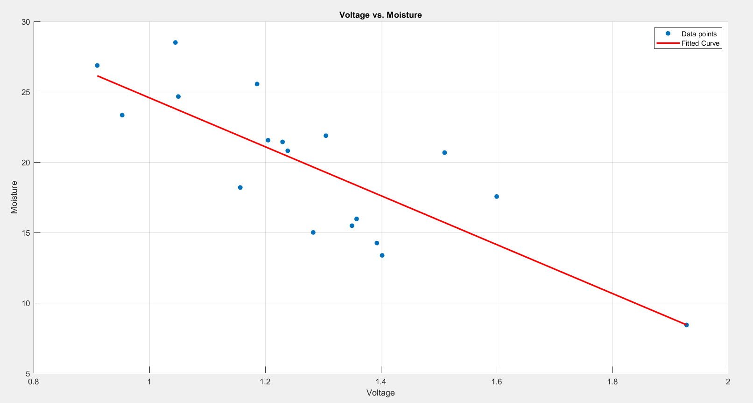

After cleaning the data by removing few slightly non accurate values and replotting the values we got the equation as:

-19.7978 voltage + 43.8087

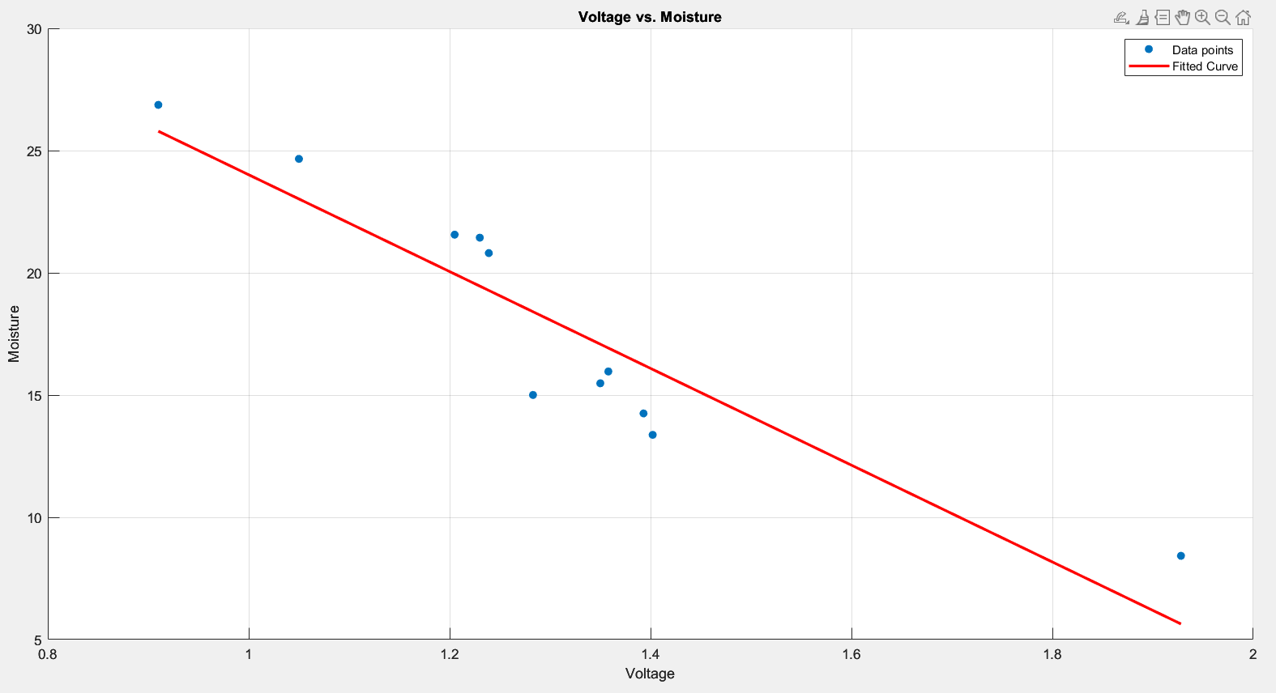

Now by using this equation we are finding the moisture content of the grains based on the photodiode reverse saturation current (i.e. by using resistor as a I-V converter).

**9. OBSERVATIONS**

The observations we made are primarily divided as what were the problems we have encountered and how did we solve them, what are the limitations or constraints on which our model depends, here is the detailed analysis of both of these sections:

**9.1 PROBLEMS ENCOUNTERED**

During the development of solution, we have faced many problems and some of the problems are:

**Sample preparation**

During the sample preparation to apply constant weight method to obtain the true moisture content of the grains, we have used beaker in which 50g of sample was placed and kept in a hot air oven.

This method has raised many concerns and didn’t give us the desired result because the water content was unable to get evaporated from the beaker column, after observing this we have changed the vessel from beaker to china dish which has ha greater evaporating area.

**Photodiode reverse saturation current**

While measuring the reverse saturation current of the photodiodes we observed that the voltage level is fluctuating because even the room light is messing with the reverse saturation current of the photodiodes, so in order to avoid this we have used a special lid that doesn’t let any external light enter paddy grain unit of the system.

**System behaviour at no grain**

When there aren’t any grains in the paddy grain unit of the system, and the system is turned on the analog pin of the microcontroller reads a voltage value greater than the reference voltage of the microcontroller which may lead to permanent damage of the microcontroller board.

This issue can be prevented by the usage of ultrasonic sensor above the paddy grain unit which reads the situation of the paddy grain unit, ie if there are any grains in the compartment of the compartment is empty, if the compartment is empty then the analog reference voltage is not allowed to reach the analog read pin of the microcontroller using an SPDT relay module, But due to space constraints we weren’t able to implement this safety feature in this version of the model.

**Resistors overheating**

As the system gets turned on the resistors get heated up Fastly which in turn might affect the voltage reading at the ADC which also may effect the final moisture content of the grains, in order to overcome this problem we can either go for cooling system(a simple CPU fan ) or we can arrange the IR transmitters in such a way that the voltage drop across the transmitter array matches the input voltage, then we can eliminate the usage of resistors which not only mitigates this issue, this also reduces the power loss of the model.

**9.2 FACTORS EFFECTING THE OUTPUT**

There are many factors effecting the output of our designed model some of them include:

**Quantization error and resolution of ADC**

Once the microcontroller converts the analog voltage at the output of the op amp to digital voltage, in the process of converting the analog voltage to the digital format the microcontroller uses ADC which converts the analog voltage to digital format based on different quantization levels, in my case any voltage changes less than 3.2mv is ignored by the microcontroller because:

(vref/1024=3.3/1024=3.22mv)

**Power dissipation across resistors**

In the circuit that we have designed for IR transmitter array we need 0.7A of current to be sent to the IR transmitter array and at the same time as all the IR transmitters are connected in parallel, we need to also take care of the voltage drop across them.

compensating all these we have used 8-ohm paper resistors, these paper resistors get heated up if the devices is kept powered on for longer period of time, as the temperature of the resistor increases accordingly its resistance also increases which reduces the current supplied to the Transmitter array which in turn reduces the reverse saturation current flowing through the photodiodes. This effects our calculations.

**Op-amp non-inverting amplifier**

Here we are using op-amp non inverting amplifier for amplifying the voltage drop across the resistor due to the reverse saturation current of the photo diodes, if the voltage drop across the resistor increases greater than 2v the output of the Op amp enters the saturation stage and the output doesn’t vary linearly with the input, this effect the moisture calculations in the microcontroller.

**Reference voltage of the microcontroller**

The reference voltage of the microcontroller we have used is 3.3v so the microcontroller cannot see the voltage variations beyond 3.3v, so this is also a limitation, even though the moisture voltage level in this case doesn’t cross 2.12v, this is also one of the constraints to be taken care of.

**10. APPLICATIONS**

This model can be used to measure the moisture content of different kinds of grains starting from paddy to maize, wheat and many other grains. Some of the grains whose moisture content can be measured by this kind of models are :

1. Rice
2. Wheat
3. Corn/Maize
4. Barley
5. Oats
6. Milo
7. Rye
8. Millet
9. Quinoa
10. Buckwheat

Measuring the moisture content of these grains is crucial in various industries such as agriculture, food processing, and storage to ensure quality control, proper storage conditions, and prevent spoilage.

**11.COMMERCIAL SCOPE**

The selling point of this model is small range farmers, as the model is cost efficient, we can further reduce the model cost by making a customised embedded system just for this application which reduces the project cost by 40-50%.

Coming to scalability we can add as many varieties of grains as possible to this model, if we are unable to get the curve using a standard method we can choose a precise moisture meter and get the curve in reference with it and using the curve obtained our model can be trained to generate moisture values of the grains wrt voltage variations of the grain content.

So, this model can function as a replica for any highly accurate moisture meters present in the market without the need of applying the constant weight method again and again for calibration, however the accurate accuracy percentage can only be determined wrt comparisons made between our model and the moisture content given by the constant weight method.

**12. FUTURE SCOPE**

In future we look forward to scale this model for different grain models so and add a feature of calibration so that the device can be calibrated time to time so as to prevent wrong readings by the instrument.

We aim to design a custom embedded system so that the system consumes less power and use less space so that the model can look more compact and sleeker.

We aim to look more accurate methods, i.e. we can employ two methods and take an average of these methods so the output would be more accurate than a single method model, example is we can employ dielectric method as well as this NIR spectroscopy method in the same system to improve model accuracy.

So, in short, our future scope is to further improve the accuracy of the model, at the same time bring down the cost of the model and also make it scalable to more than one grain type.

**13. CONCLUSION**

To conclude, we have reached our project objectives and designed a simple and cost-effective grain moisture meter which is easy to use by anyone and is scalable to large set of grain ranges.

Our project demonstrates the usage of non-destructible methods for the measurement of moisture content of the grain, Our project also talks about the establishment of relation between the moisture content of the grain and different properties like NIR spectral behaviour of water.

**14. REFERENCES**

1. “Analysis of water in food by near infrared spectroscopy” By Hans Büning-Pfaue* Institute Food Science Food Chemistry, University Bonn. D-53115 Bonn. Germany
2. Rapid-Detection Sensor for Rice Grain Moisture Based on NIRSpectroscopy Lei Lin 1,2, Yong He 1,2 , Zhitao Xiao 3, Ke Zhao 3, Tao Dong 1,2 and Pengcheng Nie 1,2
3. “Near-Infrared Spectroscopy” Akke Bakker1,2, Brianne Smith2, Philip Ainslie2 and Kurt Smith2 1University of Twente 2University of British Columbia Okanagan 1The Netherlands 2Canada